Coaxial Connectors

There are many types of connectors that are used to connect coaxial lines to RF/microwave devices. They include:
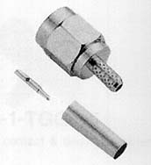
SMA
The workhorse microwave connector. Small size, but works well to > 20 GHz. By microwave standards, moderately priced.

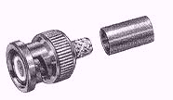
BNC
The workhorse RF connector. Relatively small and cheap, and easy to connect. Don’t use this connector past 2 GHz!

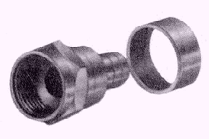
F
A poorman’s BNC. The RF connector used on most consumer products such as TVs. Cheap, but difficult to connect and not reliable.
N
The original microwave connector. Good performance (up to 18GHz), and moderate cost, but large (about 2 cm in diameter) ! However, can handle greater power than SMA.
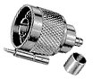

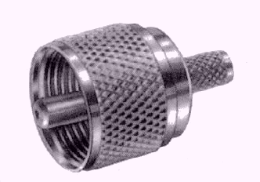
UHF
The poorman’s N. About the same size, although reduced reliability and performance.

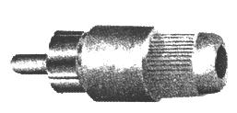
RCA
Not really an RF connector. Used primarily in consumer application for video and audio signals (i.e., <20 MHz). Cheap and easy to connect.


APC-7 and APC-3.5
The top of the line connector. Best performance, but cost big $$$. Used primarily in test equipment (e.g., network analyzers). 3.5 can work to nearly 40 GHz.

