2.1 The Ideal Op-Amp

Reading Assignment: pp. 63-66

The transistor is the fundamental circuit element of modern electronics. We can use transistors to form very complex circuits that do all sorts of useful and wonderful things.

Yet, with respect to analog circuits, we might argue that the fundamental electronic circuit element is the operational amplifier, otherwise known as the op-amp.

Now, an op-amp is actually an integrated circuit that implements dozens, or even hundreds of transistors.
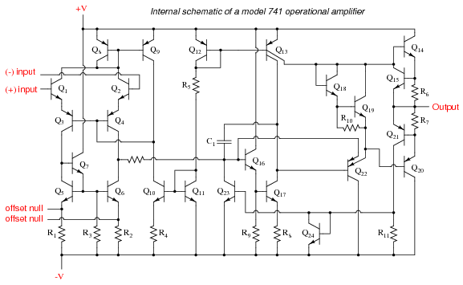

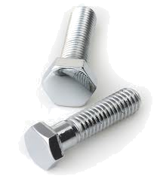
Q: So, how could such a complex circuit be considered to be a fundamental circuit element?

A: Despite its complexity, the behavior of an op-amp is simple and straight forward. In fact, we will find that the math describing op-amp operation is far simpler than the math describing transistor operation!

Likewise, we will find that (like the transistor) an op-amp by itself is a mostly useless device. Instead we must construct a circuit around it to achieve utility.
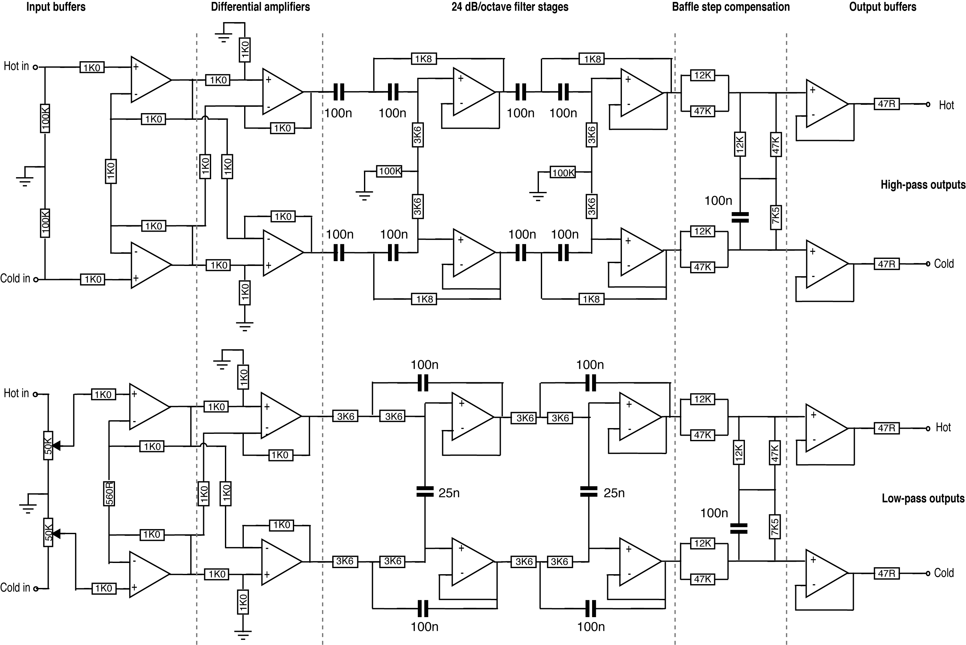

From: www.soton.ac.uk/~apm3/diyaudio/DAXO.html

And—like a transistor—the utility that we can achieve with an op-amp circuit is both vast and substantial.

In other words, the applications of op-amps to analog circuit design are nearly limitless!

Let’ start by examining the characteristics of an ideal op-amp!

HO: The Ideal op-amp

