Example: An op-amp
circuit analysis

Let’s determine the output voltage v_{out} (t) of the circuit below:

R₂ =3K
R₁ = 1K
+
-
ideal
R₃ =1K
v_{out} (t)
v_{in} (t)
I=2 mA

Without this step, your answer (and
thus your grade) mean nothing

The first step in EVERY circuit analysis problem is to label all currents and voltages:
R₂ =3K
R₁ = 1K
+
-
ideal
R₃ =1K
v_{out}
v_{in}
I=2 mA
The search for a template…

Q: I looked and looked at the notes, and I even looked at the book, but I can’t seem to find the right equation for this configuration!

A: That’s because the “right equation” for this circuit does not exist—at least yet.

It’s up to you to use your knowledge and your skills to determine the “right equation” for the output voltage !

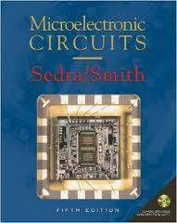
You have the tools to determine this yourself—no need to find a template!

Q: OK, let’s see; the output voltage is:

????

I’m stuck. Just how do I determine the output voltage?


A: Open up your circuit analysis tool box. Note it consists of three tools and three tools only:

Tool 1: KCL

Tool 2: KVL

Tool 3: Device equations (e.g., Ohm’s Law and the virtual short).

Let’s use these tools to determine the “right” equation!

First, let’s apply KCL (I’m quite partial to KCL).
The first KCL

Note there are two nodes in this circuit. The KCL for the first node is:

R₂ =3K
R₁ = 1K
+
-
ideal
R₃ =1K
v_{out}
v_{in}
I=2 mA

Note the potential of this node (with respect to ground) is that of the inverting op-amp terminal (i.e., ).
The second KCL

The KCL of the second node is:

R₂ =3K
R₁ = 1K
+
-
ideal
R₃ =1K
v_{out}
v_{in}
I=2 mA

Note the potential of this node (with respect to ground) is that of the non-inverting op-amp terminal (i.e., ).
The first KVL

Now for our second tool—KVL.

We can conclude:

R₂ =3K
R₁ = 1K
+
-
ideal
R₃ =1K
v_{out}
v_{in}
I=2 mA

The second KVL

And also:

R₂ =3K
R₁ = 1K
+
-
ideal
R₃ =1K
v_{out}
v_{in}
I=2 mA

The third KVL

And likewise:
R₂ =3K
R₁ = 1K
+
-
ideal
R₃ =1K
v_{out}
v_{in}
I=2 mA
There are seven device equations

Finally, we add in the device equations.

Note in this circuit there are three resistors, a current source, and an op-amp

From Ohm’s Law we know:

And from the current source:

And from the op-amp, three equations!

12 equations and 12 unknowns!

Q: Yikes! Two KCL equations, three KVL equations, and seven device equations—together we have twelve equations. Do we really need all these?

A: Absolutely! These 12 equations completely describe the circuit. There are each independent; without any one of them, we could not determine !

To prove this, just count up the number of variables in these equations:

We have six currents:

And six voltages:

Together we have 12 unknowns—which works out well, since we have 12 equations!

Thus, the only task remaining is to solve this algebra problem!

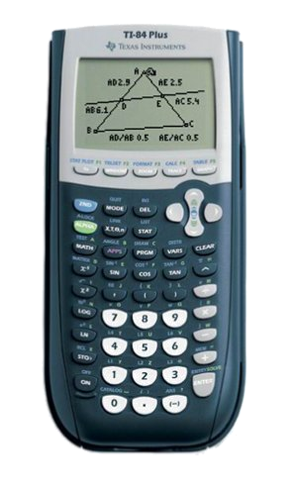
Don’t ask the calculator
to figure this out!

Q: OK, here’s where I take out my trusty programmable calculator, type in the equations, and let it tell me the answer!

A: Nope. I will not be at all impressed with such results (and your grade will reflect this!).

Instead, put together the equations in a way that makes complete physical sense—just one step at a time.


i3 = 2 mA

First, we take the two device equations:

and

And from the second KCL equation:

R₂ =3K
R₁ = 1K
+
-
ideal
R₃ =1K
v_{out}
v_{in}
I=2 mA

So v3 = 2.0 V

Now that we know the current through , we can determine the voltage across it (um, using Ohm’s law…).

R₂ =3K
R₁ = 1K
+
-
ideal
R₃ =1K
v_{out}
v_{in}
I=2 mA

Thus v- = 2.0 V

Thus, we can now determine both (from a KVL equation) and (from a device equation):
and

R₂ =3K
R₁ = 1K
+
-
ideal
R₃ =1K
v_{out}
v_{in}
I=2 mA

And now i1 =i2 +2

Now, inserting another device equation:

into the first KCL equation:

R₂ =3K
R₁ = 1K
+
-
ideal
R₃ =1K
v_{out}
v_{in}
I=2 mA

So that v2 = 2- vout

From KVL we find:

and:

R₂ =3K
R₁ = 1K
+
-
ideal
R₃ =1K
v_{out}
v_{in}
I=2 mA

Now we can find vout

So, from Ohm’s law (one of those device equations!), we find:

and:

Equating these last two results:

The “right equation” !

Thus, we have at last arrived at the result:

R₂ =3K
R₁ = 1K
+
-
ideal
R₃ =1K
v_{in}
I=2 mA

An alternative: superposition

Note an alternative method for determining this result is the application of superposition.

First we turn off the current source (e.g., )—note that this is an open circuit!!!!!!!!
R₂ =3K
R₁ = 1K
+
-
ideal
R₃ =1K
v_{in}
I=0

It’s just an inverting amp

Note this is the same configuration as that of an inverting amplifier!

Thus, we can quickly determine (since we already know!) that:

R₂ =3K
R₁ = 1K
+
-
ideal
R₃ =1K
v_{in}

See if you can prove this result!

Likewise, if we instead set the input source to zero (—ground potential!), we will find that the output voltage is 14 volts (with respect to ground):
R₂ =3K
R₁ = 1K
+
-
ideal
R₃ =1K
I=2 mA

Look; the answer is the same!

From superposition, we conclude that the output voltage is the sum of these two results:

The same result as before!
R₂ =3K
R₁ = 1K
+
-
ideal
R₃ =1K
v_{in}
I=2 mA

