Closed-Loop Bandwidth

Say we build in the lab (i.e., the op-amp is not ideal) this amplifier:
+
-
R₂
R₁
v₋
v₊
i₁
i₂
i₋ =0
i₊ =0

We know that the open-circuit voltage gain (i.e., the closed-loop gain) of this amplifier should be:
???

This gain will certainly be accurate for input signals at low frequencies .

As the signal frequency increases

But remember, the Op-amp (i.e., open-loop gain) gain decreases with frequency.

If the signal frequency becomes too large, the open-loop gain will become less than the ideal closed-loop gain!

0 dB

The amp gain cannot
exceed the op-amp gain

Note as some sufficiently high frequency ( say), the open-loop (op-amp) gain will become equal to the ideal closed-loop (non-inverting amplifier) gain:

Moreover, if the input signal frequency is greater than frequency , the op-amp (open-loop) gain will in fact be smaller that the ideal non-inverting (closed-loop) amplifier gain:

Q: If the signal frequency is greater than , will the non-inverting amplifier still exhibit an open-circuit voltage (closed-loop) gain of ?

A: Allow my response to be both direct and succinct—NEVER!

Closed-loop gain < or = open-loop gain

The gain of any amplifier constructed with an op-amp can never exceed the gain of the op-amp itself.

In other words, the closed-loop gain of any amplifier can never exceed its open-loop gain.

* We find that if the input signal frequency exceeds , then the amplifier (closed-loop) gain will equal the op-amp (open-loop) gain .

* Of course, if the signal frequency is less than , the closed-loop gain will be equal to its ideal value , since the op-amp (open-loop) gain is much larger than this ideal value ).

* We now refer to the value as the mid-band gain of the amplifier.

1+R2/R1 is the midband gain

Therefore, we find for this non-inverting amplifier that:

0 dB

Can we determine this bandwidth?

Now for one very important fact: the transition frequency is the break frequency of the amplifier closed-loop gain .

Thus, we come to conclusion that is the 3dB bandwidth of this non-inverting amplifier (i.e., )!

Q: Is there some way to numerically determine this value ?

A: Of course!

Recall we defined frequency as the value where the open-loop (op-amp) gain and the ideal closed-loop (non-inverting amplifier) gains were equal:

Recall also that for , we can approximate the op-amp (open-loop) gain as:

Divide the gain-bandwidth product by gain, and you have determined the bandwidth!

Combining these results, we find:

and thus:

But remember, we found that this frequency is equal to the breakpoint of the non-inverting amplifier (closed-loop) gain .

Therefore, the 3dB, closed-loop bandwidth of this amplifier is:

This is not rocket science
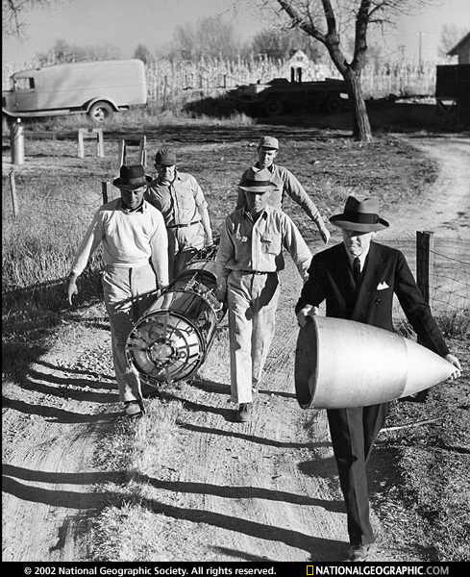
Recall also that , so that:

If we rewrite this equation, we find something interesting:

Look what this says: the PRODUCT of the amplifier (mid-band) GAIN and the amplifier BANDWIDTH is equal to the GAIN-BANDWIDTH PRODUCT.

This result should not be difficult to remember !
The gain-bandwidth product
is an op-amp parameter

The above approximation is valid for virtually all amplifiers built using operational amplifiers, i.e.:

where:

In other words, is some frequency within the bandwidth of the amplifier (e.g., ). We of course can equivalently say:

The product of the amplifier gain and the amplifier bandwidth is equal to the op-amp gain-bandwidth product!

