2.6 Large Signal Operation

Reading Assignment: 94-98

Recall that “real” amplifiers are only approximately linear!

If the input signal becomes too large, and/or the input signal changes too quickly, we begin to see some very non-linear behavior.

- Non-linear behavior leads to a distorted ouput.

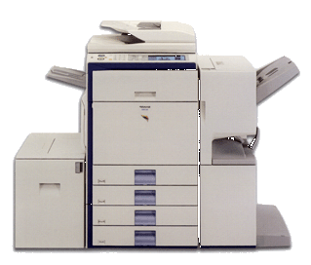
In other words, the output does not look like a copy of the input!



(A grotesque example of distortion)
The input signal cannot be too big:

HO: Output Voltage Saturation

The input signal cannot change too fast:

HO:Slew Rate

The input signal certainly cannot be too be and change too fast!

HO: Full Power Bandwidth

