Output Voltage Saturation

Recall that the ideal transfer function implies that the output voltage of an amplifier can be very large, provided that the gain A_{vo} and the input voltage v_{in} are large.
v_{out}
v_{in}
A_{vo} > 0
A_{vo} < 0
The output voltage is limited

However, we found that in a “real” amplifier, there are limits on how large the output voltage can become.

The transfer function of an amplifier is more accurately expressed as:

A non-linear behavior!

This expression is shown graphically as:

This expression (and graph) shows that electronic amplifiers have a maximum and minimum output voltage (L₊ and L₋).
v_{out}
v_{in}
A_{vo}
L₊
L₋

If the input voltage is either too large or too small (too negative), then the amplifier output voltage will be equal to either L₊ or L₋ .

If v_{out} = L₊ or v_{out} =L₋ , we say the amplifier is in saturation (or compression).

Make sure the input isn’t too large!

Amplifier saturation occurs when the input voltage is greater than:

or when the input voltage is less than:

Often, we find that these voltage limits are symmetric, i.e.:

For example, the output limits of an amplifier might be L₊ = 15 V and L₋ = -15 V.

However, we find that these limits are also often asymmetric (e.g., L₊ = +15 V and L₋ = +5 V).
Saturation: Who really cares?

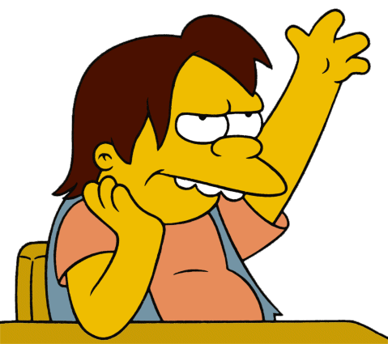
Q: Why do we care if an amplifier saturates? Does it cause any problems, or otherwise result in performance degradation??



A: Absolutely! If an amplifier saturates—even momentarily—the unavoidable result will be a distorted output signal.
A distortion free example

For example, consider a case where the input to an amplifier is a triangle wave:
v_{in} (t)
t

Since for all time t, the output signal will be within the limits L₊ and L₋ for all time t, and thus the amplifier output will be v_{out} (t) = A_{vo} v_{in} (t):
v_{out} (t)
t

The input is too darn big!

Consider now the case where the input signal is much larger, such that for some time t (e.g., the input triangle wave exceeds the voltage limits and some of the time):
v_{in} (t)
t

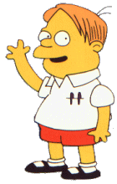

This is precisely the situation about which I earlier expressed caution.

We now must experience the palpable agony of signal distortion!
Palpable agony
v_{out} (t)
t

Note that this output signal is not a triangle wave!

For time t where , the value is greater than L₊ and less than L₋, respectively.

Thus, the output voltage is limited to for these times.

As a result, we find that output does not equal —the output signal is distorted!
Amplifiers with op-amps

For amplifiers constructed with op-amps, the voltage limits L₊ and L₋ are determined by the DC Sources V ⁺ and V ⁻ :

and

+
-
v_{in}
v_{out}
ideal
R₂
R₁

