MOSFET Biasing using a Single Power Supply

The general form of a single-supply MOSFET amplifier biasing circuit is:
+

-
+

-

Just like BJT biasing, we typically attempt to satisfy three main bias design goals:

1) Maximize Gain

Typically, the small-signal voltage gain of a MOSFET amplifier will be proportional to transconductance :

Thus, to maximize the amplifier voltage gain, we must maximize the MOSFET transconductance.

Q: What does this have to do with D.C. biasing?

A: Recall that the transconductance depends on the DC excess gate voltage:

Another way to consider transconductance is to express it in terms of DC drain current . Recall this DC current is related to the DC excess gate voltage (in satureation!) as:

And so transconductance can be alternatively expressed as:

Therefore, the amplifier voltage gain is typically proportional to the square-root of the DC drain current:

To maximize , maximize

2) Maximize Voltage Swing

Recall that if the DC drain voltage is biased too close to , then even a small small-signal drain voltage can result in a total drain voltage that is too large, i.e.:

In other words, the MOSFET enters cutoff, and the result is a distorted signal!

To avoid this (to allow to be as large as possible without MOSFET entering cutoff), we need to bias our MOSFET such that the DC drain voltage is as small as possible.

Note that the drain voltage is:

Therefore is minimized by designing the bias circuit such that the DC drain current is as large as possible.

However, we must also consider the signal distortion that occurs when the MOSFET enters triod. This of course is avoided if the total voltage drain-to-source remains greater than the excess gate voltage, i.e.:

Thus, to avoid the MOSFET triode mode—and the resulting signal distortion—we need to bias our MOSFET such that the DC voltage is as large as possible.

To minimize signal distortion, maximize

3) Minimize Sensitivity to changes in

We find that MOSFETs are sensitive to temperature—specifically, the value of is a function of temperature.

Likewise, the values of and threshold voltage are not particularly constant with regard to the manufacturing process.

Both of these facts lead to the requirement that our bias design be insensitive to the values of and . Specifically, we want to design the bias network such that the DC bias current does not change values when and/or does.
Mathematically, we can express this requirement as minimizing the value:
and

Similar to the BJT, we find that these derivatives are minimized by maximizing the value of source resistor .

To minimize , maximize

So, let’s recap what we have learned about designing our bias network:

1. Make as large as possible.

2. Make as large as possible.

3. Make as large as possible.

Again analogous to BJT biasing, we find that these three goals are conflicting, as they are constrained by the KVL equation of the bias circuit:

+

-
+

-

or

Maximize A_{vo} by maximizing this term.

Minimize distortion by maximizing this term.

Minimize sensitivity by maximizing this term.

But the total of the three terms must equal this!

Resolving this conflict is a subject choice of the amplifier designer. However, here is a “rule-of-thumb” procedure.

However, verify that these results satisfy your design requirements (or the requirements assigned to you by your boss and/or professor!).

1. Given the desired value of I_{D}, make source voltage , i.e. set the source resistor to:

(1)

This value reduces the sensitivity !

2. Now determine the required value of . Since , we find that should be:

3. Set the required value of gate voltage .

Note that:

Thus, we can add the results of the previous two steps to find the required value of the gate voltage .

To set the gate voltage to this value, we must select the proper values of resistors .

Since the gate current is zero (), we find from voltage division that:

(2)

Note this equation determines the ratio of resistors , but not the resistors themselves.

We need a second equation to explicitly determine the resistors values—the sum of the two resistances, for example.

We find that making the resistances as large as possible is very desirable! This will typically maximize the amplifier input resistance, as well as result in minimum power dissipation.

As a result, we make the resistors as large a practicable. For example:
(3)

4. Set the required value of DC drain voltage .

Recall that:

a) we require to avoid cutoff mode.

b) and, we require that to avoid triode mode.

Solution: set the drain voltage to a value half-way between and !

In other words, set the DC drain voltage to be:

To achieve this, we must select the drain resistor so that:

(4)

Thus, use equations (1), (2), (3), and (4) to determine the standard DC bias design (i.e., ) for MOSFET amplifiers.
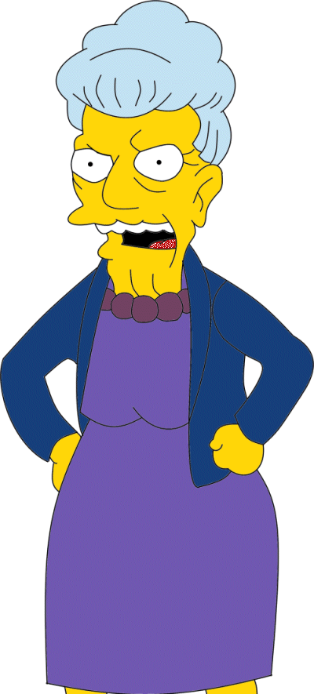

If I were you, I’d make sure I understood this material well enough that I could also bias a non-standard MOSFET amplifier problem.

It’s not enough to simply know how, you must also know why!

