The Emitter Capacitor:
What’s up with that?

Note that in a previous amplifier example, there is a mysterious capacitor attached to the emitter:
Q: Why is this big capacitor here? Is it really required?
+
-

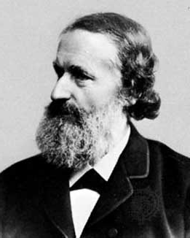

A: Let’s do a small-signal analysis and see why we place this large capacitor at the emitter.
Let’s analyze this amplifier!

Step 1 – DC Analysis

This is already completed! Recall that we designed the single supply DC bias circuit such that:
and

Step 2 – Calculate the BJT small-signal parameters

If we apply the hybrid-π model, we will require the small signal parameters:

This is step 3…

Steps 3 and 4 – Replace the BJT with its small-signal equivalent circuit , and turn off all DC sources.

Tuning off the DC sources, and replacing the Capacitors Of Unusual Size with short circuits, we find that the circuit becomes:

+
-

…and this is step 4

Now carefully replace the BJT with its small-signal model:
3.7 K
R_{C} =1 K
+

v_{be}

-
B
C
E
2.3 K
+
-

Note that , therefore our small-signal circuit is equivalently:

R_{C} =1 K
+

v_{be}

-
+
-

A hefty gain

Step 5 – Analyze the small-signal circuit.

Since for this circuit and , the open-circuit, small-signal voltage gain of this amplifier is:

Likewise, we can find that the small-signal input and output resistances are:

and

Note that the gain in this case is fairly large—46 dB.

Still, what’s up with the capacitor?

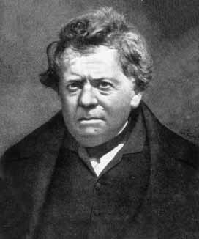
Q: I still don’t understand why the emitter capacitor is required.

Sure, our amplifier has large voltage gain, but I don’t see how a capacitor could be responsible for that.

A: To see why the emitter capacitor is important, we need to compare these results to those obtained if the emitter capacitor is removed.

Note that if we remove the emitter capacitor, the first two steps of the small-signal analysis remains the same—the DC operating point is the same, and thus the small-signal parameters remain unchanged.

However, this does not mean that our resulting small signal circuit is left unchanged!

The emitter resistor is not “shorted out”!

- Recall that large capacitors (COUS) are approximated as AC shorts in the small-signal circuit.

- The emitter capacitor thus “shorts out” the emitter resistor in the small-signal circuit—the BJT emitter is connected to small-signal ground.

- If we remove the emitter capacitor, the emitter resistor is no longer shorted, and thus the BJT emitter is no longer connected to ground!

A horse of an entirely different color

The small-signal circuit in this case is:
3.7 K
R_{C} =1 K
+

v_{be}

-
B
C
E
2.3 K
R_{E} =1 K
+
-

Note that the resistors and are no longer in parallel with base resistance !

As are result, we find that small signal voltage v_{be} is not equal to small signal input voltage v_{i}.

This circuit—it’s harder

Note also that the collector resistor is not connected in parallel with the dependent current source!
+
-
R_{C} =1 K
+

v_{be}

-
B
C
E
R_{E} =1 K
i_{b}
i_{c}
i_{e}
+
v_{e}
-

Analyzing this small-signal circuit is not so easy!

We first need to determine the small signal base-emitter voltage in terms of input voltage .

Start with KCL

From KCL, we know that:

Where:

Therefore:

And now for KVL

+
-
R_{C} =1 K
+

v_{be}

-
B
C
E
R_{E} =1 K
i_{b}
i_{c}
i_{e}
+
v_{e}
-

Likewise, from KVL:

This is NOT voltage division!

Inserting this into the first KCL result:

And now solving for small-signal emitter voltage:

Note that the small-signal base voltage is not related to the small signal input voltage by voltage division, i.e.:

!!!

vbe is really small!

Therefore, we can finally determine in terms of input voltage :

Note then that not only is , the small-signal base-emitter voltage is much smaller than input voltage !

This of course is evident from the relationship:

which states that the emitter voltage is approximately equal to the base (input) voltage .

Now for the output voltage

This result will have a profound impact on amplifier performance!

To determine the output voltage, we begin with KCL:

+
-
R_{C} =1 K
+

v_{be}

-
B
C
E
R_{E} =1 K
i_{b}
i_{c}
i_{e}
+
v_{e}
-
i_{r}

What a wimpy gain

Now applying Ohm’s Law to R_{C}:

But recall that:

so we find that the small-signal output voltage is:

And thus the open-circuit voltage gain of this amplifier is:

See, the emitter capacitor is important

Yikes! Removing the emitter capacitor cause the voltage gain to change from –200 (i.e., 46 dB) to approximately –1.0 (i.e., 0dB)—a 46 dB reduction!

That emitter capacitor makes a big difference!

We can likewise finish the analysis and find that the small-signal input and output resistances are:

Note that input resistance actually improved in this case, increasing in value from 370 Ω to 1.42 K Ω.

However, the decrease in voltage gain makes this amplifier (without a emitter capacitor) almost completely useless.

He only knows this because
your TA explained it to him

The amplifier in this case (with the emitter capacitor) is an example of a design known as a common-emitter amplifier.

There are an infinite number of common-emitter designs, but they all share one thing in common—the emitter of the BJT is always connected directly to small-signal ground.

Common-emitter amplifier, such as the one examined here, typically result in large small-signal voltage gain (this is good!).

However, another characteristic of common emitter amplifiers is a typically low small-signal input resistance and high small-signal output resistance(this is bad!).

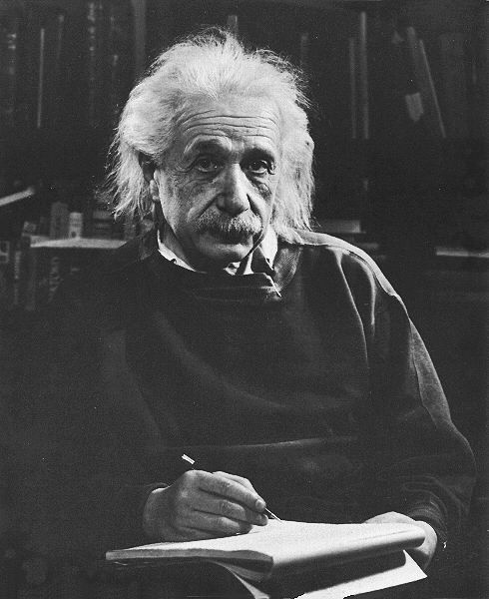
Make sure you can answer this question

One way to construct a common-emitter amplifier without using an emitter capacitor is simply to connect the BJT emitter directly to ground:
+
-

In this case, the emitter is at both AC (small-signal) ground and DC ground!

Q: Why is this common-emitter design seldom used??

A:

