Amplifier Bandwidth

BJT amplifiers are band-limited devices—in other words, they exhibit a finite bandwidth.

Q: ???

A: Say the input to a BJT small-signal amplifier is the eigen function of linear, time-invariant system:

Since the small-signal BJT amp is (approximately) a linear system, the output will likewise be the eigen function—an undistorted sinusoidal function of precisely the same frequency as the input!

Amplifier

Q: Of course that’s true! We know that:

Therefore the magnitudes of the input and output sinusoids are related as:
Right?

A: Not necessarily!

The small-signal, open-circuit voltage gain of a BJT amplifier depends on the frequency of the input signal!

Q: Huh!?! We determined earlier that the small-signal voltage gain of this amplifier:
+
-

was:

So then if the small-signal input is:

isn't the small-signal output simply:

?????????

A: Maybe—or maybe not!

Again, the gain of the amplifier is frequency dependent. We find that if is too high (i.e., large) or too low (i.e., small), then the output might be much less than the 200 times larger than the input (e.g., only 127.63 times larger than the input—Doh!).

Now, the signal frequencies for which

is an accurate statement, are frequencies that are said to lie within the bandwidth of this amplifier (is just right!).

Conversely, frequencies for which:

are frequencies that lie outside this amplifier’s bandwidth.

Fortunately, the frequencies that compose an amplifier’s bandwidth typically form a continuum, such that the frequencies outside this bandwidth are either higher or lower than all frequencies within the bandwidth.

Perhaps a plot would help.

The frequencies between and thus lie within the bandwidth of the amplifier. The gain within the bandwidth is sometimes referred to as the midband gain.

For signals with frequencies less than , the amplifier gain will be less than the midband gain—likewise for frequencies greater than .

Q: So what then is the value:

determined for the example amplifier? It doesn’t seem to be a function of frequency!

A: The value -200 calculated for this amplifier is the midband gain—it’s the gain exhibited for all signals that lie within the amplifier bandwidth. Your book at times uses the variable A_{M} to denote this value:

Q: So it’s actually the midband gain that we’ve been determining from our small-signal circuit analysis (e.g. )?

A: That’s exactly correct!

Q: So how do we determine the frequency dependent gain ? More specifically, how do we determine midband gain , along with and ?

A: The function is simply the eigen value of the linear operator relating the small-signal input and the small signal output:

Q: Yikes! How do we determine the eigen value of this linear operator?

A: We simply analyze the small-signal circuit, determining in terms of .

Specifically, we must explicitly consider the capacitance in the small-signal amplifier—no longer can we make approximations!

So, instead of vaguely labeling large capacitors as Capacitors Of Unusual Size, let’s explicitly consider the exact values of these large capacitors:

+
-

Likewise, we must consider the parasitic capacitances of the BJT—specifically and .

The small-signal circuit—when we explicitly consider these capacitances—is thus:

3.7 K
1 K
B
C
E
2.3 K
1 K
+
-

We analyze this circuit to determine , and then the eigen value—the small-signal gain—is determined as:

Q: So what again is the meaning of and ?

A: It’s the Fourier transform of and !

and

Q: So—I can’t recall—what’s the relationship between and ?

A: If:

Then in the time domain, we find that the input and output are related by the always enjoyable convolution integral!!!

where the impulse response of the amplifier is of course:

Q: What the heck? What happened to solutions like:

??

A: This result implies that the impulse response of the amplifier is:

Such that:

Q: You say that the result:

“implies” that the impulse response of the amplifier is:

Are you saying the impulse response of the common-emitter example is not this function?

A: It is definitely not that function. The impulse response

is ideal—the impulse response of an amplifier with an infinite bandwidth!

Q: So all our small-signal analysis up to this point has been incorrect and useless???

A: Not at all! The small-signal gain we have been evaluating up to this point (e.g., -200) is the amplifier midband gain A_{M} .

As long as the small-signal input resides completely within the amplifier bandwidth, then the output will be:

The problem occurs when the input signal lies—at least partially—outside the amplifiers bandwidth.

In that case, we find that:

And instead:

where:

and the eigen value is determined by evaluating this small-signal circuit:
3.7 K
1 K
B
C
E
2.3 K
1 K
+
-

Q: What do you mean when you say that a signal lies “within the amplifier bandwidth” or “outside the amplifier bandwidth?
How can we tell?

A: Use the Fourier Transform!

If we plot the magnitude of the Fourier Transform of the input signal , we can see the spectrum of the input signal:

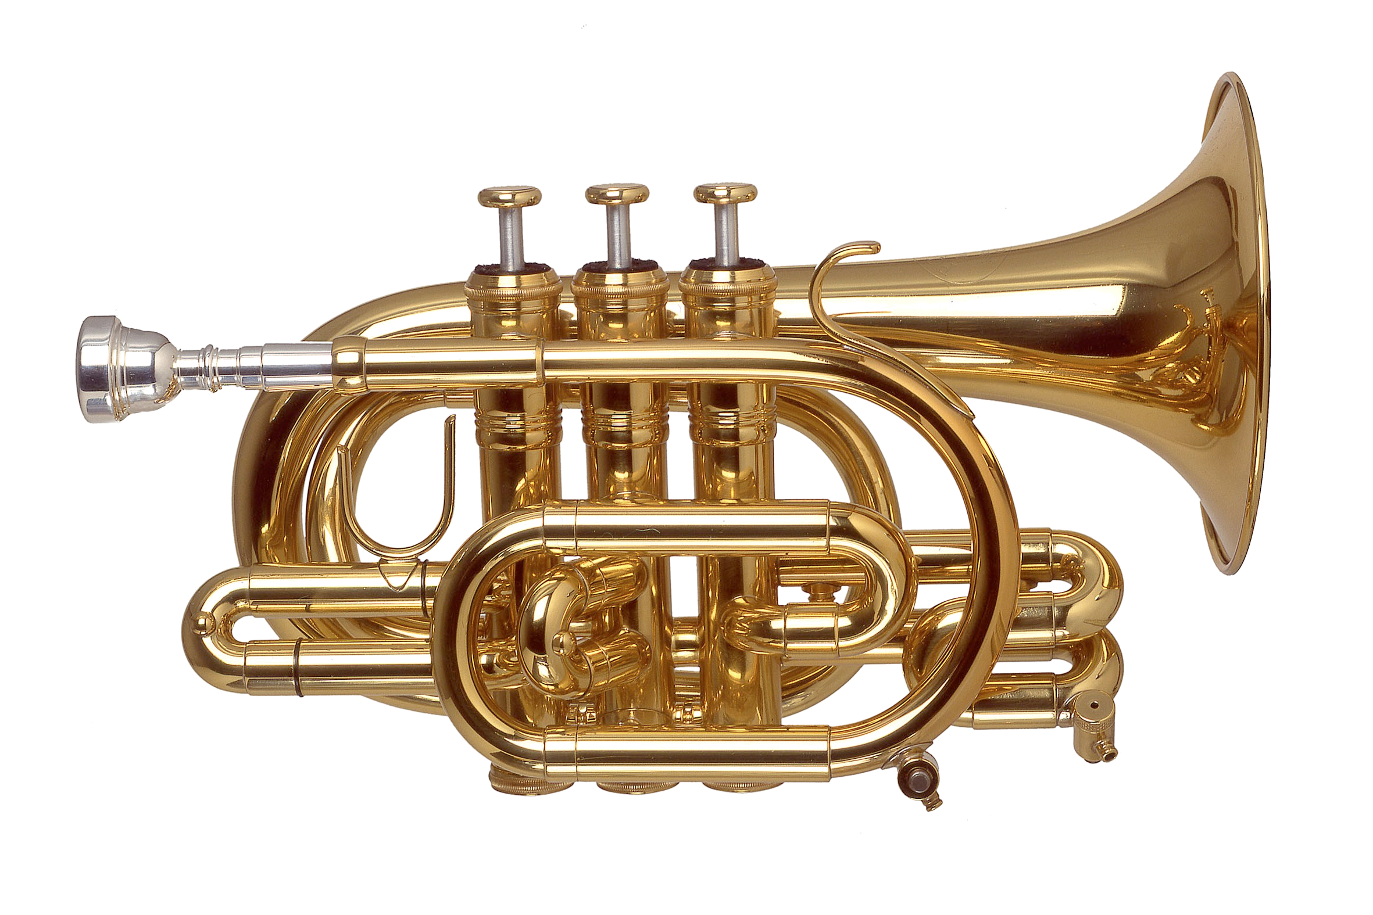
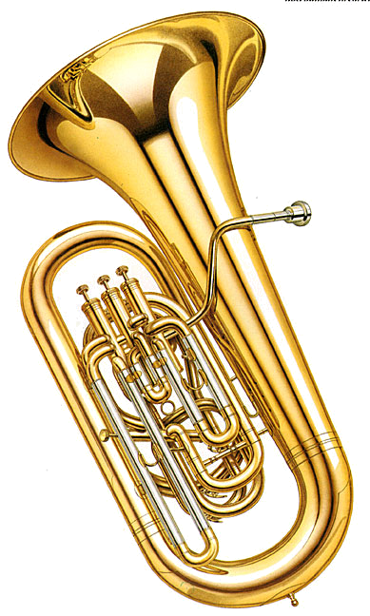
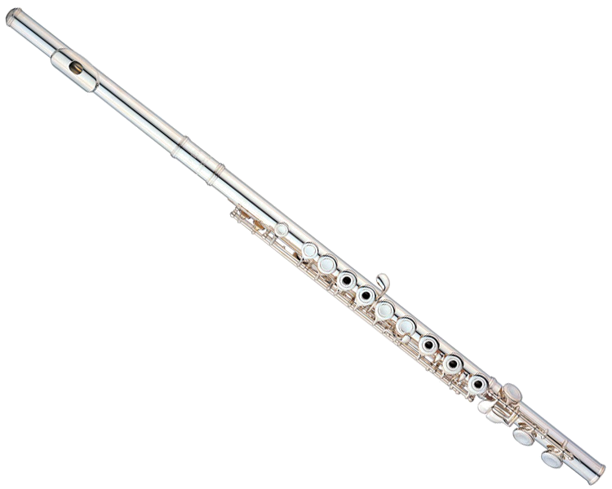

For example, if you are attempting to amplify a signal representing the audio of symphonic music, the spectrum will include low-frequency signals (e.g., from the tubas), mid-range frequency signals (e.g., from the trumpets), and high-frequency signals (e.g., from the flutes).

Now, if it is your desire to reproduce exactly this music at the output of your amplifier, then the amplifier bandwidth must be wide enough to include all these spectral components !

For the case above, the input signal resides completely within the bandwidth of the amplifier (i.e., between and ), and so we find (for ) that:

and:

However, if the input spectrum resides (at least partially) outside the amplifier bandwidth, e.g.:

then we find that:

and:
!!!!

Instead, we find the more general (and more difficult!) expressions:

and:

where the impulse response of the amplifier is:

Q: So just what causes this amplifier to have a finite bandwith?

A: For mid-band frequencies (i.e., between ), we will find that the Capacitors Of Unusual Size exhibit an impedance that is pretty small—approximately an AC short circuit:

Likewise, the tiny parasitic capacitances and exhibit an impedance that is very large for mid-band frequencies—approximately an open circuit:

However, when the signal frequency drops too low, the COUS will no longer be a small-signal short.

The result is that the amplifier gain is reduced—the values of the COUS determine the low-end amplifier bandwidth .

Likewise, when the signal frequency is too high, the parasitic caps will no longer be a small-signal open.

The result is that the amplifier gain is reduced—the values of the parasitic capacitors determine the high-end amplifier bandwidth .

