6.5 The Common Source
Amp with Active Loads

Reading Assignment: pp. 582-587

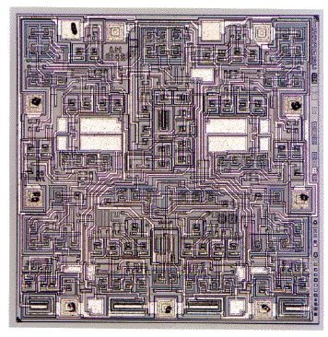
Amplifiers are frequently made as integrated circuits (e.g., op-amps).

Although both BJTs and MOSFET integrated circuit amplifiers are implemented as ICs, we find that MOSFETs amplifiers are almost exclusively implemented as integrated circuits (i.e., rarely are MOSFET amps made of “discrete” components).

Making integrated circuit amplifiers has many positives, but a few negatives:

Positives:

The amplifier circuit can be quite complex, yet still small and inexpensive. Thus, current sources are “no big deal”.

Negatives:

We cannot make large capacitors (i.e., COUS), so that DC blocking capacitors are not possible—this makes bias solutions more complex, particularly for multi-stage amplifiers.

Additionally, it if difficult to make resistors in integrated circuits. Instead, we use “resistors” constructed from transistors—so-called “active loads”.

HO: Enhancement loads

HO: The Common Source Amp with an Active Load

The sensitivity problem of the previous circuit can be solved using a current source as a “load”

HO: The Common Source Amp with a Current Source

