Large-Signal Operation
of the MOSFET
Differential Pair

Consider now the MOSFET differential pair:
Figure 7.1 The basic MOS differential-pair configuration.

Note:

and

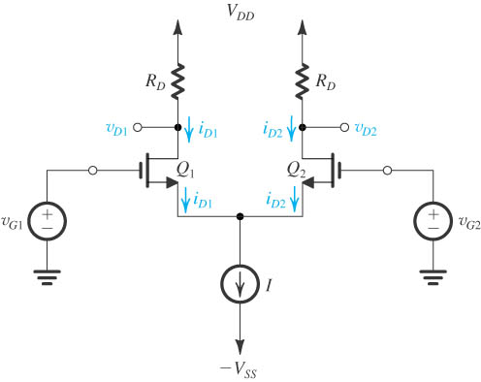

If each of the transistors are in saturation, then each drain current must be:

where

Therefore, we define the differential input voltage as:


Now, doing just a bunch of algebra, we can combine all of the above equations to find the drain current for each transistor:



Note this result shows that the drain current of each transistor is dependent only on the differential signal
—the drain currents are independent of the common-mode (i.e., average) input signal!

Note then, that if:

Both transistors will be in saturation and will share the available current evenly:

For this case, Q₁ is in cutoff and we find that:

whereas transistor Q₂ remains in saturation and “takes” all the available current:

For this case, Q₂ is now in cutoff and we find that:

whereas Q₁ is the transistor that remains in saturation and “takes” all the available current:

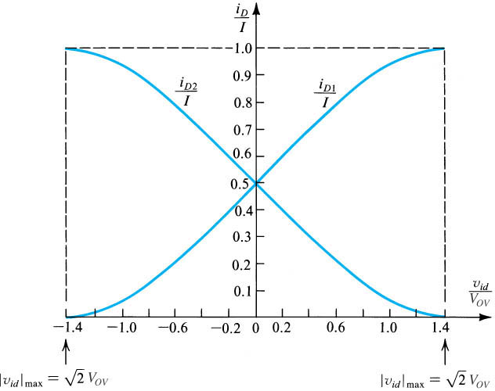
In this region, both transistors are in saturation, and the drain current through each transistor is described using the two equations given earlier. Plotting these equations, we find:

Figure 7.6 Normalized plots of the currents in a MOSFET differential pair.

Note that the derivates (i.e., slopes) of these curves are approximately constant in the center region of the plot (i.e., the region where is small).

This should not surprise us! If we look at the two equations for drain current:

we find that the last product term will approximately equal one:

Thus, we can approximate the drain currents for the case when the differential voltage as:

Now we can find the slope of the curves above by taking the derivative with respect to differential voltage v_{D}:

The slopes (derivatives) are approximately constant for small v_{D} –just as we observed they were in the plots above!

Q: These derivative values likewise tell us something very important about the behavior of the MOSFET differential pair, do you know what these derivatives tell us ?

A:

