Input Bias Current and Input Offset Current

Since each BJT in a differential pair are ideally identical, each would (ideally) have the same value for β:

(in our dream world)

However, the unfortunate reality is that these two BJT values are slightly different!

(in the harsh, cold, real world)

Since the difference between the two values is small, we define what is essentially a common-mode (average) and differential mode (difference) beta:

so that:

Assuming that each emitter takes half the available DC current, i.e.:

the DC base (input) currents are:



Now, since is small compared to β, we can approximate the above equations using a Taylor Series Approximation!

Recall from chapter 2 that the Input Bias Current (I_{B}) of our differential inputs is simply the average of the DC input currents:
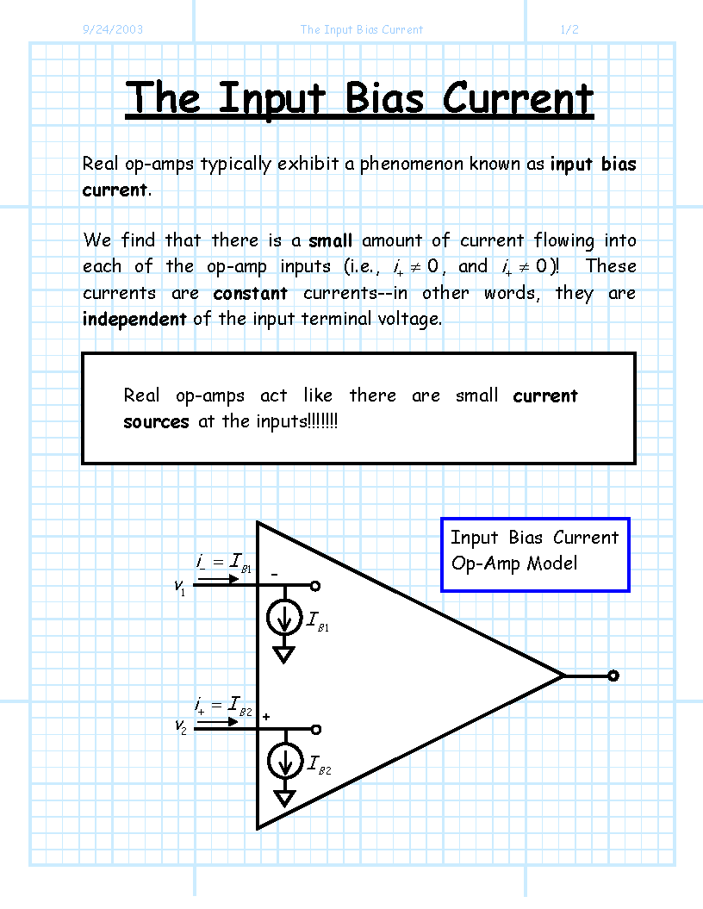

while the Input Offset Current (I_{os}) is equal to the magnitude of the difference in the two bias currents:



Look what this means! The value
is simply the geometric (e.g. percent) error of BJT parameter β. Thus, we find that the Input Offset Current is simply the Input Bias Current (I_{B}) times the “percent error” (
) between the two BJT values
and
.

