The Differential Pair Input Offset Voltage

Recall that in chapter 2 we studied about a phenomenon known as the Input Offset Voltage.
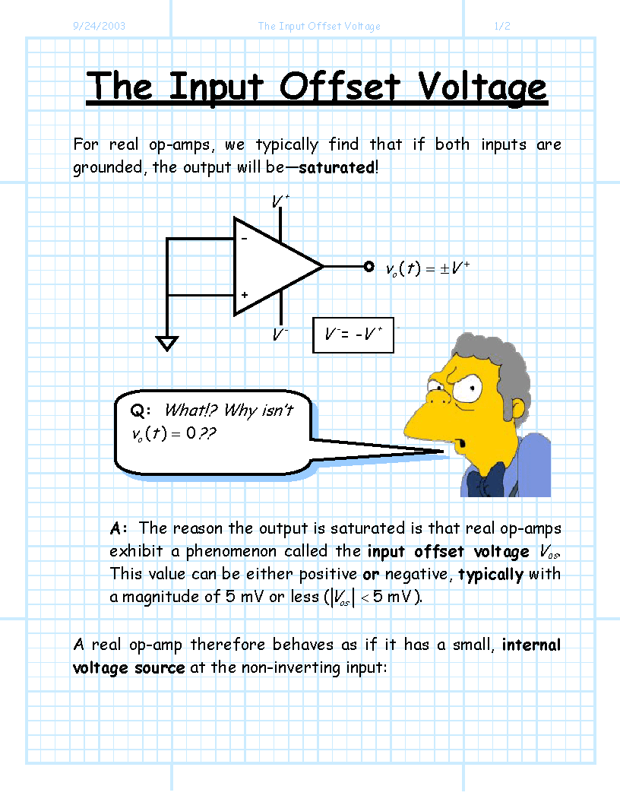

For an op-amp (a differential amplifier!) we found that when the differential input was zero (i.e., ), the output voltage was typically not zero (i.e., )!.

We found that the differential amplifier (op-amp) behaved as if it had a small DC Input Offset Voltage V_{OS}, such that a better mathematical description of the op-amp output was:

Note then if the differential input is zero (i.e., ), the output will be a DC value:

The Input Offset Voltage is therefore:

Q: Is there a similar phenomenon present for the BJT differential pair?

A: Yup! The BJT differential pair is of course a differential amplifier, a thus will likewise exhibit an Input Offset Voltage V_{OS}.

Q: What would cause this input offset voltage?

A: Either Collector Load Mismatch or Scale Current Mismatch !

