Basis Functions

Q: So let’s be specific. You say a continuous analog signal can be expressed as a discrete sequence of values , given some set of known functions . What are these functions , and what are the values ? Please give examples!

A: The functions are known as the basis functions of signal expansion:


There are essentially an infinite number of basis functions to choose from, but here are some of our favorites!

1. Polynomial

Consider basis functions of the form:

Resulting in a polynomial of variable t:

This signal expansion is of course know as the Taylor Series expansion.
2. Fourier

Among the most popular basis is this one:

So therefore:

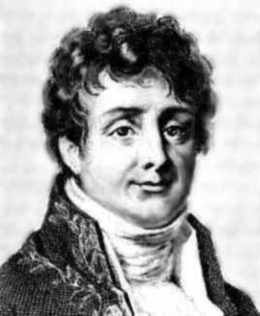

The astute among you will recognize this signal expansion as the Fourier Series!

Q: Yes, just why is Fourier analysis so prevalent?

A: The basis functions of Fourier Analysis are the eigen-functions of linear time-invariant systems (like linear circuits)!!

Q: OK Poindexter, all eigen stuff this might be interesting if you’re a mathematician, but is it at all useful to us electrical engineers?

A: It is unfathomably useful to us electrical engineers!

Say a linear, time-invariant circuit is excited (only) by a sinusoidal source (e.g., ). Since the source function is the eigen function of the circuit, we will find that at every point in the circuit, both the current and voltage will have the same functional form.

That is, every current and voltage in the circuit will likewise be a perfect sinusoid with frequency !!
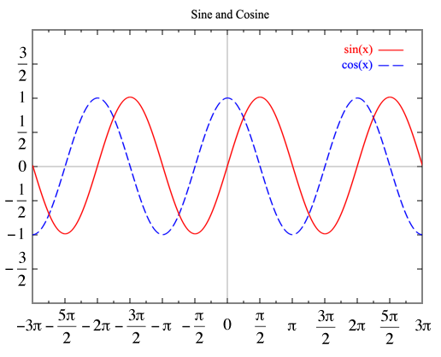
Of course, the magnitude of the sinusoidal oscillation will be different at different points within the circuit, as will the relative phase. But we know that every current and voltage in the circuit can be precisely expressed as a function of this form:

Q: Isn’t this pretty obvious?

A: Why should it be? Say our source function was instead a square wave, or triangle wave, or a sawtooth wave. We would find that (generally speaking) nowhere in the circuit would we find another current or voltage that was a perfect square wave (etc.)!
In fact, we would find that not only are the current and voltage functions within the circuit different than the source function (e.g. a sawtooth) they are (generally speaking) all different from each other.
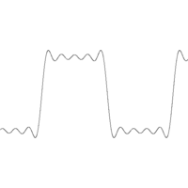

We find then that a linear circuit will (generally speaking) distort any source function—unless that function is the eigen function (i.e., an sinusoidal function).

Thus, using an eigen function as circuit source greatly simplifies our linear circuit analysis problem. All we need to accomplish this is to determine the magnitude A and relative phase of the resulting (and otherwise identical) sinusoidal function!

3. Sinc Function

As popular as the Fourier basis function is, an even more popular set of basis functions is the sinc basis function.

A sinc function is defined as:
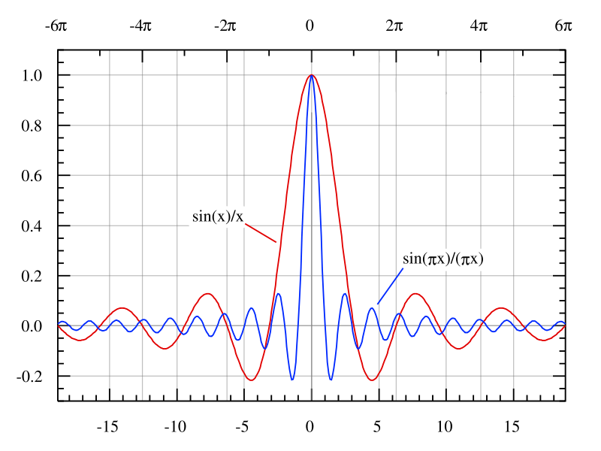

The set of basis functions derived from this are:

Q: Is this function likewise an eigen function of linear time-invariant systems?

A: Nope. Sinusoids are the ONLY eigen function of linear time-invariant systems!

Q: So why then are these basis functions so popular?

A: Determining the sequence of values for this signal expansion, i.e.,

is extremely easy (at least when compared to other basis functions)!!!

4. Wavelet Basis Functions
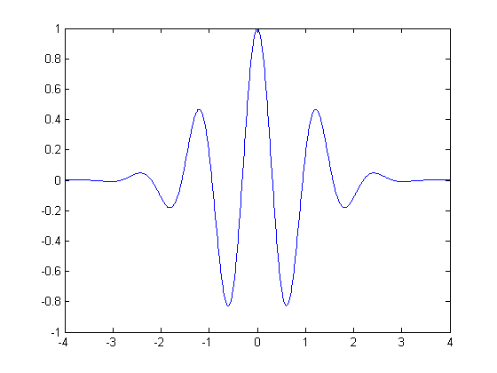



The past twenty years has shown the rise of a new kind of signal basis function, known as the wavelet basis function (watch for future math Nobel Prize ← winners).

There are many wavelet basis functions (e.g., Daubechies), but they all are a bit of a hybrid between the sinc and Fourier basis functions.

Q: Why have they become so popular?

A: Ultimately, we would like to accurately represent our signal with a discrete sequence of values that is as short as possible.

Theoretically, we require an infinite number of values to ensure that our representation has no error:

(bummer!)

However, we find that typically we can represent our function with very good accuracy using a finite number of values :

For Fourier basis functions, the number of required values defines our signal bandwidth B.

For sinc basis functions, the number of required values defines our signal timewidth T.

We find that many useful signals exist over a wide timewidth T, and a wide bandwidth B—only not necessarily at the same time.
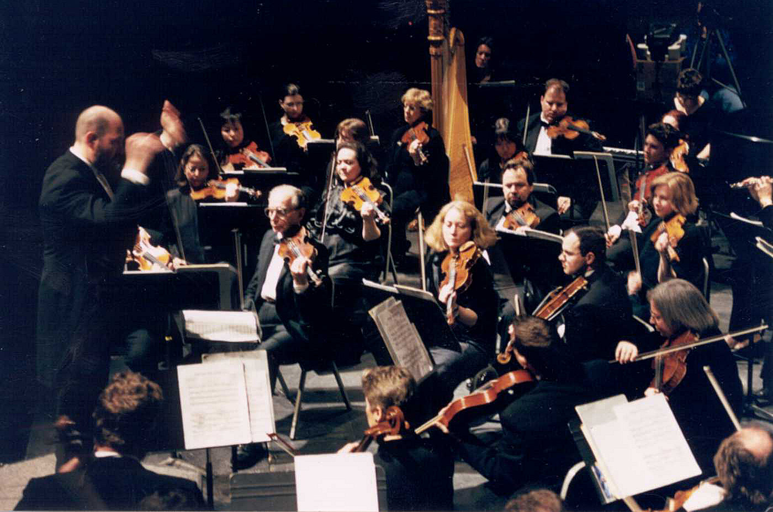

The classic example is music, where all different notes occur within a song, only not all at the same time.
Wavelet basis functions allow a signal to be more localized simultaneously in time and frequency. The result often leads to a fewer number of values (i.e., fewer than Fourier or sinc) required to accurately describe the signal.
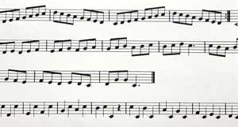

→ This is the “basis” of JPEG and MPEG compression algorithms!

We simply retain only the values of deemed large enough to be “significant”.


Original
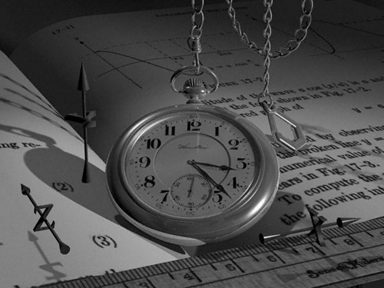
Moderate
compression

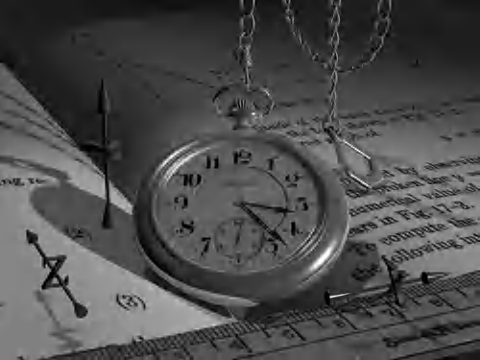
Significant
compression

http://watermarking.unige.ch/Checkmark/attacks/examples_wavelet.htm

