Circuit Models for Amplifiers

The two most important amplifier circuit models explicitly use the open-circuit voltage gain 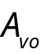:
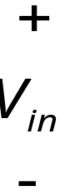
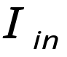
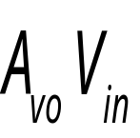
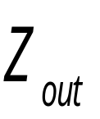
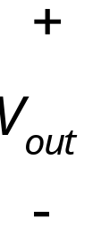
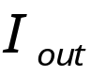
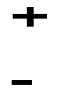

And the short-circuit current gain 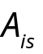:


Just three values describe all!

In addition, each equivalent circuit model uses the same two impedance values—the input impedance 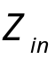 and output impedance 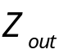.

Q: So what are these models good for?

A: Say we wish to analyze a circuit in which an amplifier is but one component.

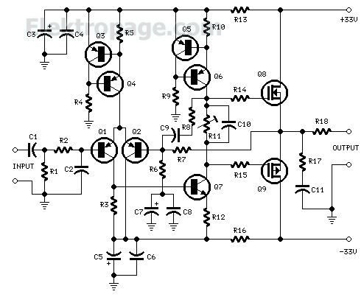
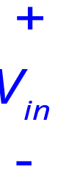
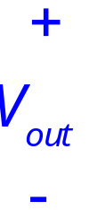
Instead of needing to analyze the entire amplifier circuit, we can analyze the circuit using the (far) simpler equivalent circuit model.

For example, consider this audio amplifier design:

This might be on the final

Say we wish to connect a source (e.g., microphone) to its input, and a load (e.g., speaker) to its output:
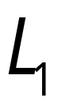
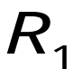

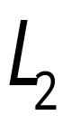
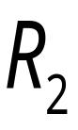
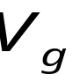
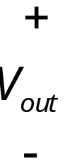

Let’s say on the EECS 412 final, I ask you to determine  in the circuit above.

I’m not quite the jerk I appear to be!


Q: Yikes! How could we possibly analyze this circuit on an exam—it would take way too much time (not to mention way too many pages of work)?

A: Perhaps, but let’s say that I also provide you with the amplifier input impedance , output impedance , and open-circuit voltage gain .

You thus know everything there is to know about the amplifier!

Just replace the amplifier with its equivalent circuit:
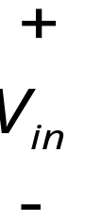

The relationship between
input and output voltages

From input circuit, we can conclude (with a little help from voltage division):

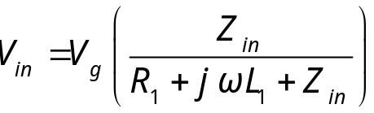

And the output circuit is likewise:

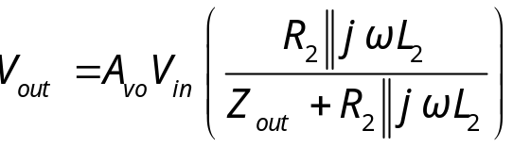

where:
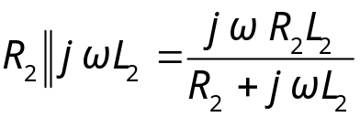

The output is not open-circuited!

Q: Wait! I thought we could determine the output voltage from the input voltage by simply multiplying by the voltage gain . I am certain that you told us:
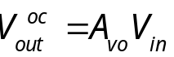

A: I did tell you that! And this expression is exactly correct.

However, the voltage 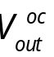 is the open-circuit output voltage of the amplifier—in this circuit (like most amplifier circuits!), the output is not open!

Hence 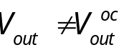, and so :

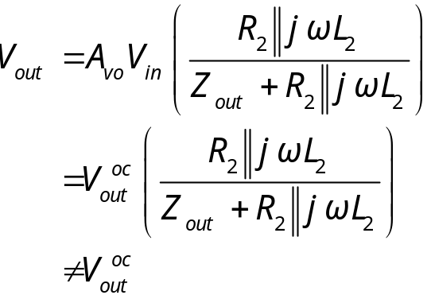

We can define a voltage gain

Now, combining the two expressions, we have our answer:

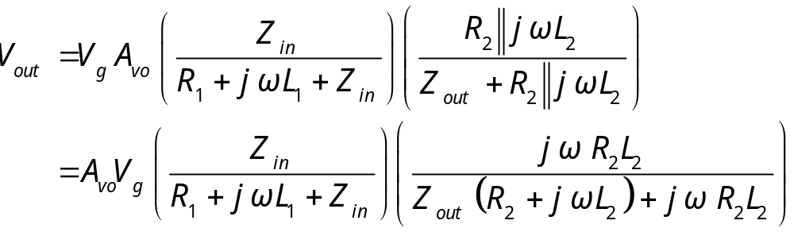

Now, be aware that we can (and often do!) define a voltage gain 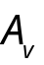, a value that is different from the open-circuit voltage gain of the amplifier.

For instance, in the above circuit example we could define a voltage gain as the ratio of the input voltage 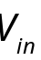 and the output voltage :

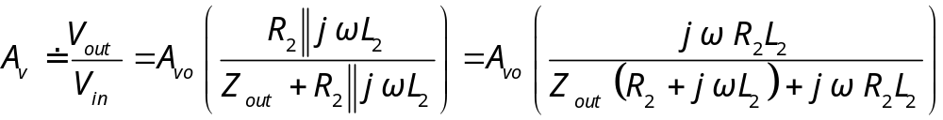

Or we can define a different gain

Or, we could alternatively define voltage gain as the ratio of the source voltage 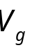 and the output voltage :

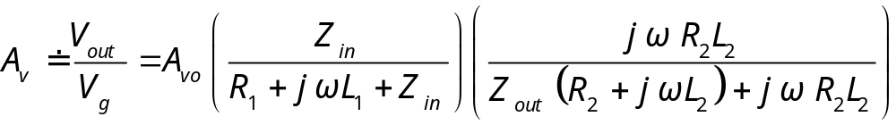

Q: Yikes! Which result is correct; which voltage gain is “the” voltage gain?

A: Both are!

We can define a voltage gain in any manner that is useful to us. However, we must make this definition explicit—precisely what two voltages are involved in the definition?

- No voltage gain is “the” voltage gain!

Note that the open-circuit voltage gain is a parameter of the amplifier—and of the amplifier only!

The open-circuit gain is the amplifier gain

Contrast to the two voltage gains defined above (i.e., 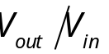 and 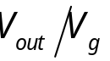).

In each case, the result—of course—depends on amplifier parameters
(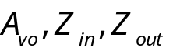).

However, the results likewise depend on the devices (source and load) attached to the amplifier (e.g., 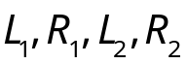).

- The only amplifier voltage gain is its open-circuit voltage gain !

The low-frequency model

Now, let’s switch gears and consider low-frequency (e.g., audio and video) applications.

At these frequencies, parasitic elements are typically too small to have any practical significance.

Additionally, low-frequency circuits frequently employ no reactive circuit elements (no capacitor or inductors).

As a result, we find that the input and output impedances exhibit almost no imaginary (i.e., reactive) components:

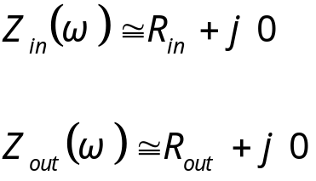

We can express this in the time domain

Likewise, the voltage and current gains of the amplifier are (almost) purely real:
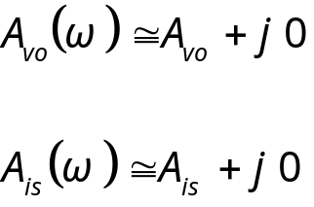

Note that these real values can be positive or negative.

The amplifier circuit models can thus be simplified—to the point that we can easily consider arbitrary time-domain signals (e.g., 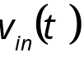 or 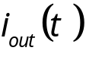):
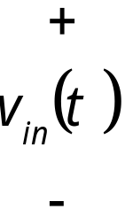
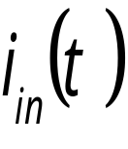
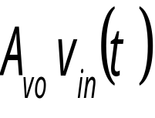
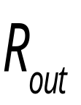
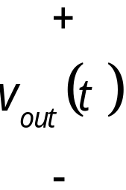
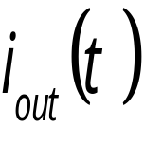

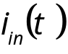

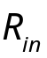

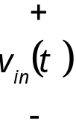
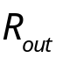
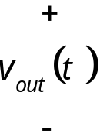
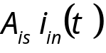

All real-valued

For this case, we find that the (approximate) relationships between the input and output are that of an ideal amplifier:

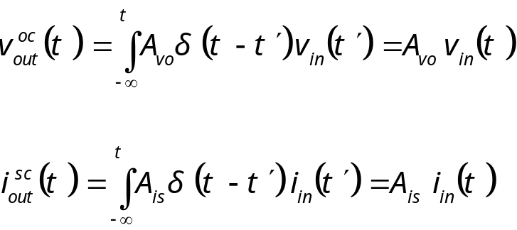

Specifically, we find that for these low-frequency models:

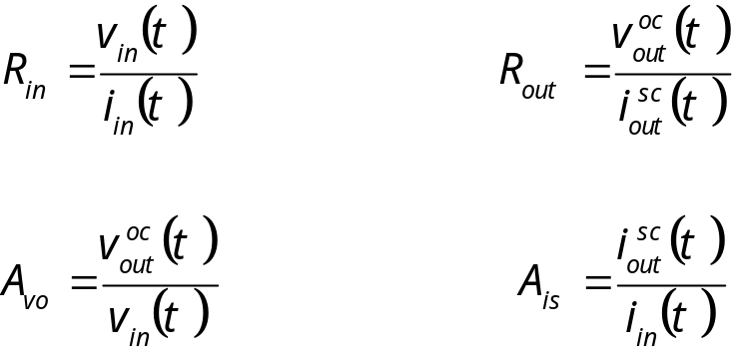

One important caveat here; this “low-frequency” model is applicable only for input signals that are likewise low-frequency—the input signal spectrum must not extend beyond the amplifier bandwidth.
Voltage is referenced to ground potential

Now one last topic.

Frequently, both the input and output voltages are expressed with respect to ground potential, a situation expressed in the circuit model as:

You’ll often see this notation

Now, two nodes at ground potential are two nodes that are connected together! Thus, an equivalent model to the one above is:

Which is generally simplified to this model:

