**Circuit Models for Amplifiers**

The two most important amplifier circuit models explicitly use the **open-circuit voltage gain** :



**

**

**

**







And the **short-circuit current gain** :



**

**

**

**





**Just three values describe all!**

In addition, each equivalent circuit model uses the **same** two **impedance** values—the **input** impedance  and **output** impedance .

**Q:** *So what are these models* ***good for****?*

**A:** Say we wish to analyze a circuit in which an amplifier is but **one** component.

Instead of needing to analyze the **entire** amplifier circuit, we can analyze the circuit using the (far) **simpler** equivalent circuit model.

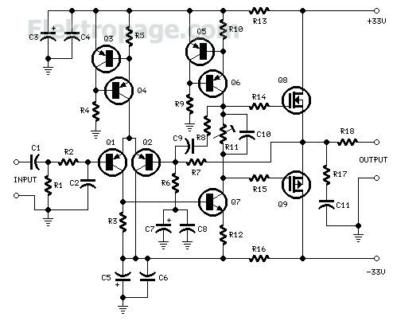

**

**

For **example**, consider **this** audio amplifier design:

**This might be on the final**

Say we wish to connect a **source** (e.g., microphone) to its **input**, and a **load** (e.g., speaker) to its **output**:

















Let’s say on the **EECS 412 final**, I ask **you** to determine  in the circuit above.

**I’m not *quite* the jerk I appear to be!**

**Q:** *Yikes! How could we* ***possibly*** *analyze this circuit on an exam—it would take way* ***too*** *much time (not to mention way* ***too*** *many pages of work)?*

**A:** Perhaps, but let’s say that I also provide you with the amplifier **input impedance** , **output impedance** , and **open-circuit voltage gain** .

You thus know **everything** there is to know about the amplifier!

Just replace the amplifier with its **equivalent circuit**:









**

**













**The relationship between**

**input and output voltages**

From **input** circuit, we can conclude (with a little help from voltage division):



And the **output** circuit is likewise:



where:



**The output is not open-circuited!**

**Q:** *Wait! I* ***thought*** *we could determine the output voltage from the input voltage by simply multiplying by the voltage gain . I am* ***certain*** *that you told us:*



**A:** I **did** tell you that! And this expression is **exactly correct**.

However, the voltage  is the **open-circuit** output voltage of the amplifier—in **this** circuit (like most amplifier circuits!), the output is **not open**!

Hence , and so :



**We can define a voltage gain**

Now, combining the two expressions, we have our **answer**:



Now, be aware that we can (and often do!) **define** a voltage gain , a value that is different from the **open-circuit** voltage gain of the **amplifier**.

For instance, in the above circuit example we could **define** a voltage gain as the ratio of the input voltage  and the output voltage :



**Or we can define a different gain**

**Or**, we could alternatively **define** voltage gain as the ratio of the source voltage  and the output voltage :



**Q:** *Yikes!* ***Which*** *result is correct; which voltage gain is* ***“the”*** *voltage gain?*

**A:** Both are!

We can **define** a voltage gain  in **any** manner that is **useful** to us. However, we must make this definition explicit—**precisely** what two voltages are involved in the definition?

* **No** voltage gain  is **“the”** voltage gain!

Note that the open-circuit voltage gain  is a parameter of the **amplifier**—and of the amplifier **only**!

**The open-circuit gain is the *amplifier* gain**

**Contrast**  to the two voltage gains defined above (i.e.,  and ).

In each case, the result—of course—depends on **amplifier** parameters

().

However, the results **likewise** depend on the devices (source and load) **attached** to the amplifier (e.g., ).

* The only **amplifier** voltage gain is its **open-circuit** voltage gain !

**The low-frequency model**

Now, let’s switch gears and consider **low-frequency** (e.g., audio and video) applications.

At these frequencies, parasitic elements are typically **too small** to have any practical significance.

Additionally, low-frequency circuits **frequently** employ **no** reactive circuit elements (no capacitor or inductors).

As a result, we find that the input and output **impedances** exhibit almost **no** **imaginary** (i.e., reactive) components:



**We can express this in the time domain**

Likewise, the voltage and current **gains** of the amplifier are (almost) purely **real**:



Note that these real values can be **positive** or **negative.**

The amplifier **circuit models** can thus be **simplified**—to the point that we can easily consider arbitrary **time-domain** signals (e.g.,  or ):

**





**



**





**

**



**

**



**

**All real-valued**

For this case, we find that the (approximate) relationships between the input and output are that of an **ideal** amplifier:



Specifically, we find that for these low-frequency **models**:



One important **caveat** here; this “low-frequency” model is applicable only for **input signals** that are **likewise** low-frequency—the input signal spectrum must **not** extend beyond the amplifier **bandwidth**.

**Voltage is referenced to ground potential**

Now one **last topic**.

Frequently, both the input and output **voltages** are expressed with respect to **ground potential**, a situation expressed in the circuit **model** as:



**

**

**

**







**You’ll often see this notation**

Now, two nodes at ground potential are two nodes that are **connected** together! Thus, an **equivalent** model to the one above is:



**

**

**

**







Which is **generally** simplified to this model:



**

**

**

**





