EECS 412 Introduction

Q: So what’s this class all about? What is its purpose?
A: In EECS 312 you learned about:
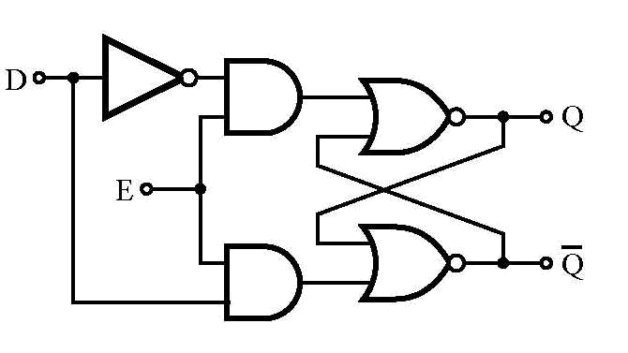
- Electronic devices (e.g., transistors and diodes)
- How we use transistors to make digital devices (e.g., inverters, gates, flip-flops, and memory).

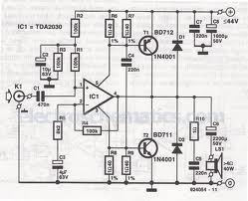

In contrast, EECS 412 will teach you how we use transistors to make analog devices (e.g., amplifiers, filters, summers, integrators, etc.).

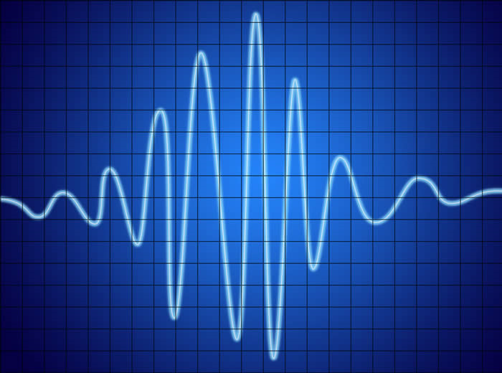
Analog circuits and devices operate on analog signals—usually voltage signals—that represent a continuous, time-varying analog of some physical function.

For example, the analog voltage signal can represent an audio pressure wave (i.e., sound), or the beating of a human heart.

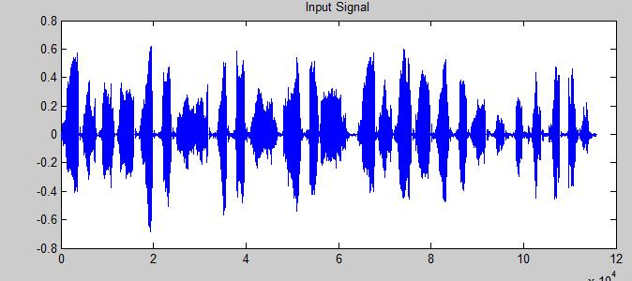

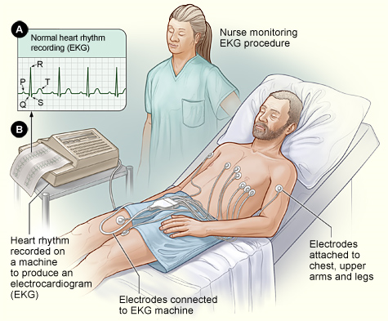
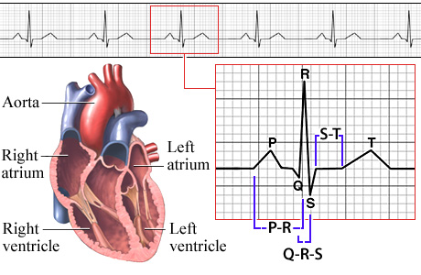

Quite often, an analog device has two ports—an input port and an output port:
Two-Port
Device

A fundamental question in electrical engineering is determining the output signal when the input signal is known.

This is frequently a difficult question to answer, but it becomes significantly easier if the two-port device is constructed of linear, time-invariant circuit elements!

HO: The Linear, Time-Invariant circuit

Linear circuit behavior would be not at all useful except for the unfathomably important concept of signal expansion via basis functions!

HO: Signal Expansions

Linear systems theory is useful for electrical engineers because most analog devices and systems are linear (at least approximately so!).

HO: Linear Circuit Elements

The most powerful tool for analyzing linear systems is its Eigen function.

HO: The Eigen Function of Linear Systems

Complex voltages and currents at times cause much head scratching; let’s make sure we know what these complex values and functions physically mean.

HO: A Complex Representation of Sinusoidal Functions

Signals may not have the explicit form of an Eigen function, but our linear systems theory allows us to (relatively) easily analyze this case as well.

HO: Analysis of Circuits Driven by Arbitrary Functions

If our linear system is a linear circuit, we can apply basic circuit analysis to determine all its Eigen values!

HO: The Eigen Spectrum of Linear Circuits

A more general form of the Fourier Transform is the Laplace Transform.

HO: The Eigen Values of the Laplace Transform

The numerical value of frequency has tremendous practical ramifications to us EEs.

HO: Frequency Bands

A set of four Eigen values can completely characterize a two-port linear system.

HO: The Impedance and Admittance Matrix

A really important linear (sort of) device is the amplifier.

HO: The Amplifier

The two most important parameter of an amplifier is its gain and its bandwidth.

HO: Amplifier Gain and Bandwidth

Amplifier circuits can be quite complex; however, we can use a relatively simple equivalent circuit to analyze the result when we connect things to them!

HO: Circuit Models for Amplifiers

One very useful application of the circuit model is to analyze and characterize types of amplifiers.

HO: Current and Voltage Amplifiers

It turns out that amplifiers are only approximately linear. It is important that we understand their non-linear characteristics and properties.

HO: Non-Linear Behavior of Amplifiers

