Frequency Bands

The Eigen value of a linear operator is of course dependent on frequency —the numeric value of depends on the frequency of the basis function .

Frequency Response

The frequency has units of radians/second; it can likewise be expressed as:

where f is the sinusoidal frequency in cycles/second (i.e., Hertz).

As a result, the function is also known as the frequency response of a linear operator (e.g. a linear circuit).


The numeric value of the signal frequency f has significant practical ramifications to us electrical engineers, beyond that of simply determining the numeric value .

These practical ramifications include the packaging, manufacturing, and interconnection of electrical and electronic devices.

The problem is that every real circuit is awash in inductance and capacitance!

Those darn parasitics!
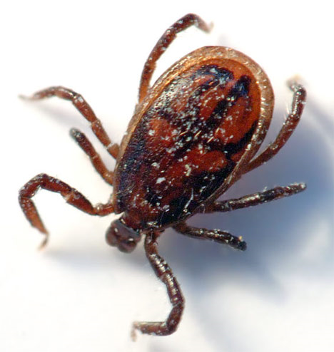
Q: If this is such a problem, shouldn’t we just avoid using capacitors and inductors?

A: Well, capacitors and inductors are particular useful to us EE’s.

But, even without capacitors and inductors, we find that our circuits are still awash in capacitance and inductance!

Q: ???

A: Every circuit that we construct will have a inherent set of parasitic inductance and capacitance.

Parasitic inductance and capacitance is associated with elements other than capacitors and inductors!

Every wire an inductor

For example, every wire and lead has a small inductance associated with it:

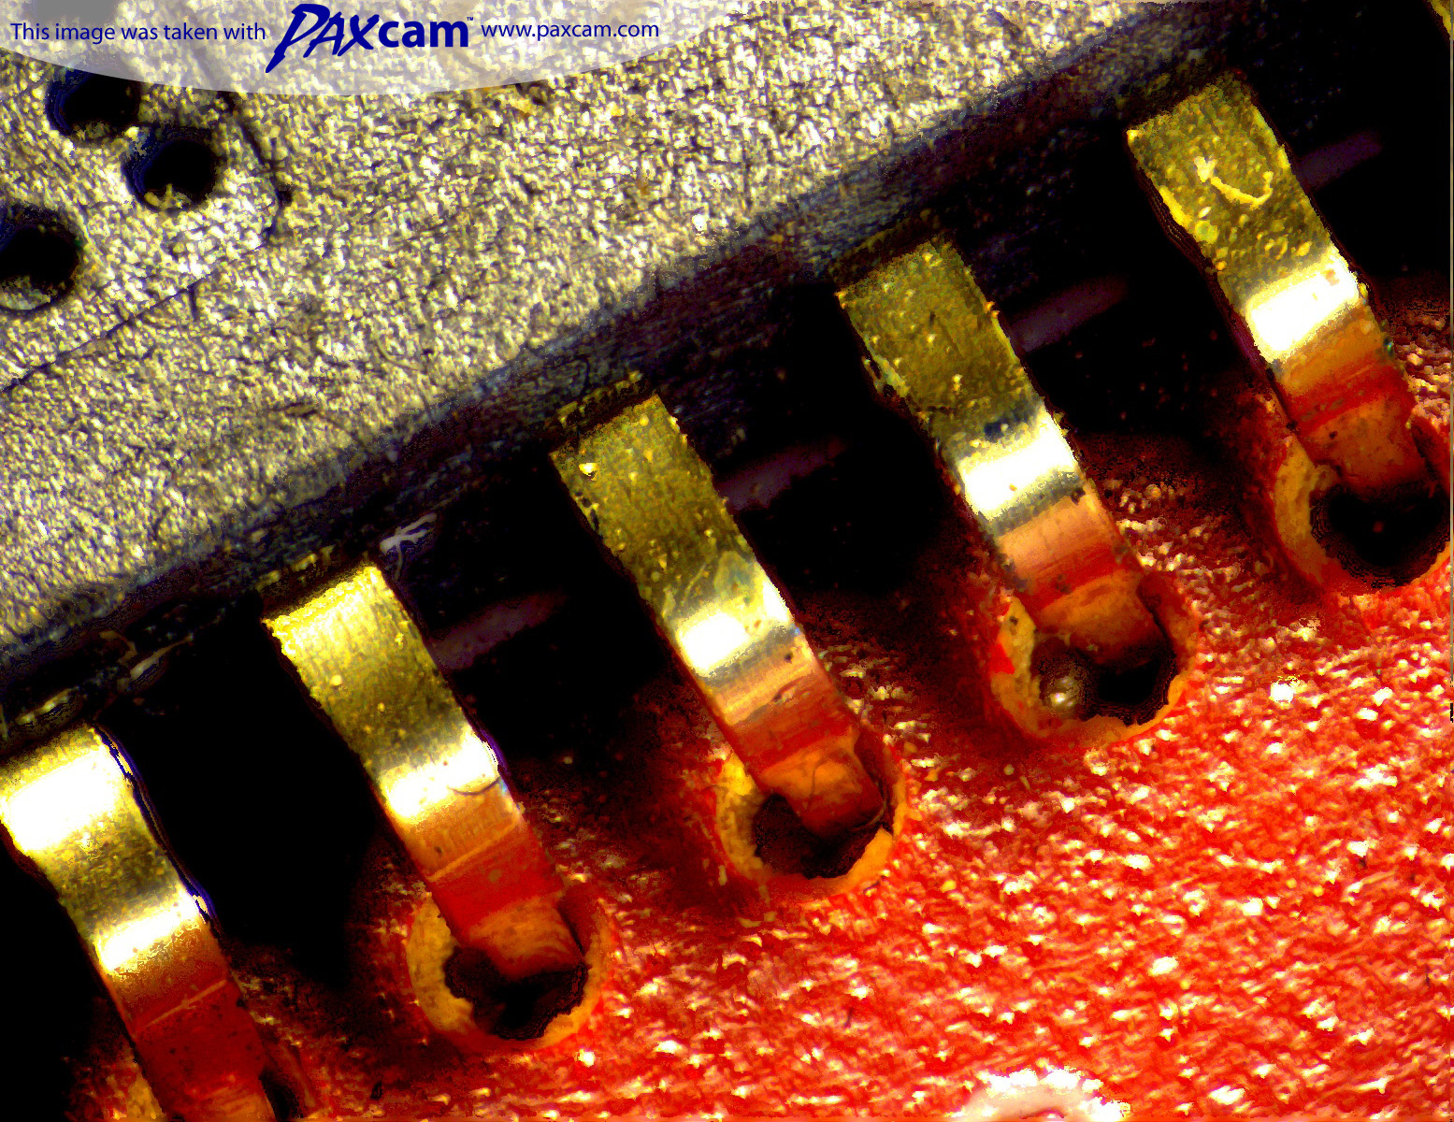
Seems simple enough…

Consider then a “wire” above a ground plane:

From KVL and KCL, we “know” that:

Thus, the linear operator (for example) relating voltage to voltage has an Eigen value equal to 1.0 for all frequencies:

…but its harder than you thought!

But, the unfortunate reality is that the “wire” exhibits inductance, and likewise a capacitance between it and the ground plane

We now see that the in fact the currents and voltage must be dissimilar:

And so the Eigen value of the linear operator is not equal to 1.0!

The parasitics are small

Now, these parasitic values of L and C are likely to be very small, so that if the frequency is “low” the inductive impedance is quite small:

(almost a short circuit!)

And, the capacitive impedance (if the frequency is low) is quite large:

(almost an open circuit!)

Thus, a low-frequency approximation of our wire is thus:

Which leads to our original KVL and KCL conclusion:

Parasitics are a problem at
“high” frequencies

Thus, as our signal frequency increases, the we often find that the “frequency response” will in reality be different from that predicted by our circuit model—unless explicit parasitics are considered in that model.

As a result, the response may vary from our expectations as the signal frequency increases!
expected
measured

Frequency Bands

For frequencies in the kilohertz (audio band) of megahertz (video band), parasitics are generally not a problem.

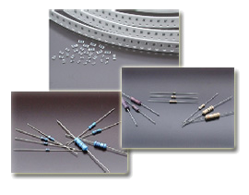
However, as we move into the 100’s of megahertz, or gigahertz (RF and microwave bands), the effects of parasitic inductance and capacitance are not only significant—they’re unavoidable!

