Linear Circuits
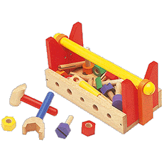
Many analog devices and circuits are linear (or approximately so).

Let’s make sure that we understand what this term means, as if a circuit is linear, we can apply a large and helpful mathematical toolbox!

Mathematicians often speak of operators, which is “mathspeak” for any mathematical operation that can be applied to a single element (e.g., value, variable, vector, matrix, or function).


...operators, operators, operators!!

For example, a function describes an operation on variable x (i.e., is operator on x ). E.G.:

Functions can be operated on

Moreover, we find that functions can likewise be operated on!

For example, integration and differentiation are likewise mathematical operations—operators that operate on functions. E.G.,:

A special and very important class of operators are linear operators.

Linear operators are denoted as , where:

- symbolically denotes the mathematical operation;

- And y denotes the element (e.g., function, variable, vector) being operated on.

We call this linear superpostion

A linear operator is any operator that satisfies the following two statements for any and all y :

1.

2. , where a is any constant.

From these two statements we can likewise conclude that a linear operator has the property:

where both a and b are constants.

Essentially, a linear operator has the property that any weighted sum of solutions is also a solution!
An example of a linear function

For example, consider the function:

At :

and at :

Now at we find:

See, it works like it’s suppose to!

More generally, we find that:

and

Thus, we conclude that the function is indeed a linear function!

Surely this is linear

Now consider this function:
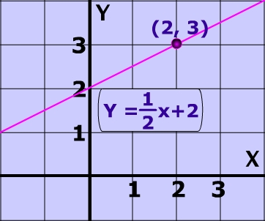

Q: But that’s the equation of a line! That must be a linear function, right?

A: I’m not sure—let’s find out!

We find that:

but:

therefore:
!!!

It’s not; and stop calling me Shirley

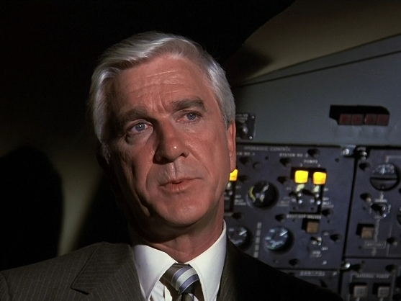
Likewise:
but:

therefore:
!!!

The equation of a line is not a linear function!

Moreover, you can show that the functions:

are likewise non-linear.

The derivative is a linear operator


Remember, linear operators need not be functions.

Consider the derivative operator, which operates on functions.

Note that:

and also:

We thus can conclude that the derivative operation is a linear operator on function :

Most operators are not linear

You can likewise show that the integration operation is likewise a linear operator:

But, you will find that operations such as:

are not linear operators (i.e., they are non-linear operators).

We find that most mathematical operations are in fact non-linear!

Linear operators are thus form a small subset of all possible mathematical operations.

Linear operators allow for “easy” evaluation

Q: Yikes! If linear operators are so rare, we are we wasting our time learning about them??

A: Two reasons!

Reason 1: In electrical engineering, the behavior of most of our fundamental circuit elements are described by linear operators—linear operations are prevalent in circuit analysis!

Reason 2: To our great relief, the two characteristics of linear operators allow us to perform these mathematical operations with relative ease!



