The Eigen Function
of Linear Systems

Recall that that we can express (expand) a time-limited signal with a weighted summation of basis functions:

where for and .

Say now that we convolve this signal with some system impulse function :

Look what happened!

Convolve with the basis
functions – not the signal

Instead of convolving the general function , we now find that we must simply convolve with the set of basis functions .

Q: Huh? You say we must “simply” convolve the set of basis functions . Why would this be any simpler?

A: Remember, you get to choose the basis . If you’re smart, you’ll choose a set that makes the convolution integral “simple” to perform!

Q: But don’t I first need to know the explicit form of before I intelligently choose ??

A: Not necessarily!

Time to use our “special” basis

The key here is that the convolution integral:

is a linear, time-invariant operator.

Because of this, there exists one basis with an astonishing property!

These special basis functions are:

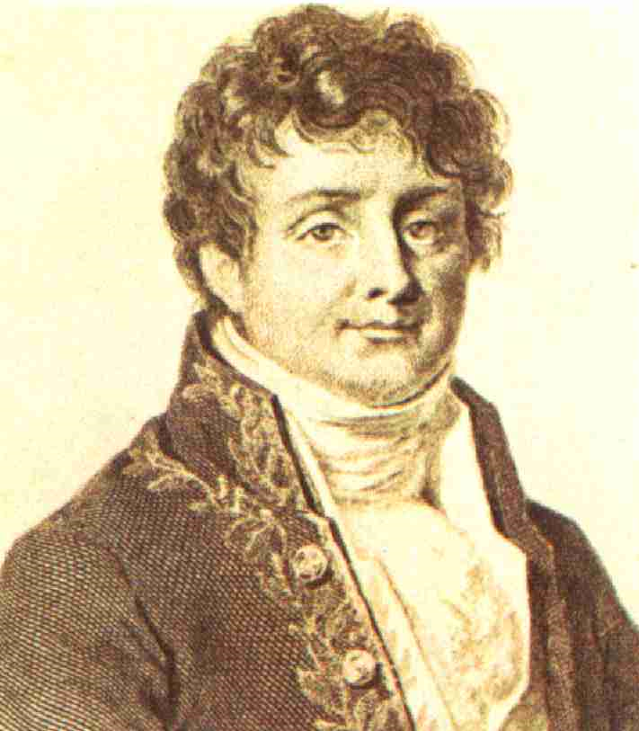

Prof. Stiles: So darn lame

Now, inserting this function (get ready, here comes the astonishing part!) into the convolution integral:

and using the substitution , we get:



See! Doesn’t that astonish!
Q: I’m only astonished by how lame you are. How is this result any more “astonishing” than any of the other “useful” things you’ve been telling us?

Convolution becomes multiplication

A: Note that the integration in this result is not a convolution—the integral is simply a value that depends on n (but not time t):

As a result, convolution with this “special” set of basis functions can always be expressed as:

The remarkable thing about this result is that the linear operation on function results in precisely the same function of time t (save the complex multiplier )! I.E.:

Convolution with is accomplished by simply multiplying the function by the complex number!
This only works for complex exponentials

Note this is true regardless of the impulse response (the function affects the value of only)!

Q: Big deal! Aren’t there lots of other functions that would satisfy the equation above equation?

A: Nope. The only function where this is true is:

This function is thus very special.

We call this function the eigen function of linear, time-invariant systems.

But complex exponentials
are two sinusoidal functions

Q: Are you sure that there are no other Eigen functions??

A: Well, sort of.

Recall from Euler’s equation that:

It can be shown that the sinusoidal functions and are likewise Eigen functions of linear, time-invariant systems.

The real and imaginary components of Eigen function are also Eigen functions.

Every linear operator has its Eigen value

Q: What about the set of values ?? Do they have any significance or importance??

A: Absolutely!

Recall the values (one for each n) depend on the impulse response of the system (e.g., circuit) only:

Thus, the set of values completely characterizes a linear time-invariant circuit over time .

We call the values the Eigen values of the linear, time-invariant circuit.
We’re electrical engineers:
why should we care?

Q: OK Poindexter, all Eigen stuff this might be interesting if you’re a mathematician, but is it at all useful to us electrical engineers?

A: It is unfathomably useful to us electrical engineers!

Say a linear, time-invariant circuit is excited (only) by a sinusoidal source (e.g., ).

Since the source function is the Eigen function of the circuit, we will find that at every point in the circuit, both the current and voltage will have the same functional form.

That is, every current and voltage in the circuit will likewise be a perfect sinusoid with frequency !!

Haven’t you wondered
why we always use these?

Of course, the magnitude of the sinusoidal oscillation will be different at different points within the circuit, as will the relative phase.
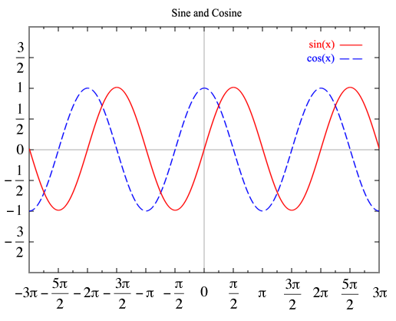

But we know that every current and voltage in the circuit can be precisely expressed as a function of this form:

Q: Isn’t this pretty obvious?

A: Why should it be?

Say our source function was instead a square wave, or triangle wave, or a sawtooth wave.

We would find that (generally speaking) nowhere in the circuit would we find another current or voltage that was a perfect square wave (etc.)!
We “just” have to determine
magnitude and phase!

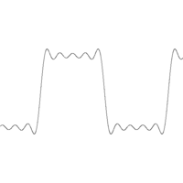

In fact, we would find that not only are the current and voltage functions within the circuit different than the source function (e.g. a sawtooth) they are (generally speaking) all different from each other.

We find then that a linear circuit will (generally speaking) distort any source function—unless that function is the Eigen function (i.e., a sinusoidal function).

Thus, using an Eigen function as circuit source greatly simplifies our linear circuit analysis problem.

All we need to accomplish this is to determine the magnitude A and relative phase of the resulting (and otherwise identical) sinusoidal function!

