The Linear, Time-Invariant System

Most of the microwave devices and networks that we will study in this course are both linear and time invariant (or approximately so).
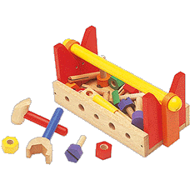
Let’s make sure that we understand what these terms mean, as linear, time-invariant systems allow us to apply a large and helpful mathematical toolbox!

Linearity

Mathematicians often speak of operators, which is “mathspeak” for any mathematical operation that can be applied to a single element (e.g., value, variable, vector, matrix, or function).

...operators, operators, operators!!

For example, a function describes an operation on variable x (i.e., is operator on x ). E.G.:

Moreover, we find that functions can likewise be operated on! For example, integration and differentiation are likewise mathematical operations—operators that operate on functions. E.G.,:

A special and very important class of operators are linear operators.

Linear operators are denoted as , where:

- symbolically denotes the mathematical operation;

- And y denotes the element (e.g., function, variable, vector) being operated on.

A linear operator is any operator that satisfies the following two statements for any and all y :

1.

2. , where a is any constant.

From these two statements we can likewise conclude that a linear operator has the property:

where both a and b are constants.

Essentially, a linear operator has the property that any weighted sum of solutions is also a solution!

For example, consider the function:

At :

and at :

Now at we find:

More generally, we find that:

and

Thus, we conclude that the function is indeed a linear function!

Now consider this function:
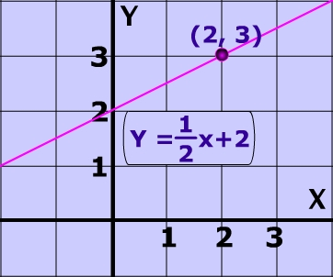

Q: But that’s the equation of a line! That must be a linear function, right?

A: I’m not sure—let’s find out!

We find that:

but:

therefore:
!!!

Likewise:
but:

therefore:
!!!

The equation of a line is not a linear function!

Moreover, you can show that the functions:

are likewise non-linear.


Remember, linear operators need not be functions. Consider the derivative operator, which operates on functions.

Note that:

and also:

We thus can conclude that the derivative operation is a linear operator on function :

You can likewise show that the integration operation is likewise a linear operator:

But, you will find that operations such as:

are not linear operators (i.e., they are non-linear operators).

We find that most mathematical operations are in fact non-linear! Linear operators are thus form a small subset of all possible mathematical operations.

Q: Yikes! If linear operators are so rare, we are we wasting our time learning about them??

A: Two reasons!

Reason 1: In electrical engineering, the behavior of most of our fundamental circuit elements are described by linear operators—linear operations are prevalent in circuit analysis!

Reason 2: To our great relief, the two characteristics of linear operators allow us to perform these mathematical operations with relative ease!

Q: How is performing a linear operation easier than performing a non-linear one??

A: The “secret” lies is the result:

Note here that the linear operation performed on a relatively complex element can be determined immediately from the result of operating on the “simple” elements and .
To see how this might work, let’s consider some arbitrary function of time , a function that exists over some finite amount of time T (i.e., ).

Say we wish to perform some linear operation on this function:

Depending on the difficulty of the operation , and/or the complexity of the function , directly performing this operation could be very painful (i.e., approaching impossible).

Instead, we find that we can often expand a very complex and stressful function in the following way:


where the values are constants (i.e., coefficients), and the functions are known as basis functions.

For example, we could choose the basis functions:

Resulting in a polynomial of variable t:

This signal expansion is of course know as the Taylor Series expansion. However, there are many other useful expansions (i.e., many other useful basis ).

- The key thing is that the basis functions are independent of the function . That is to say, the basis functions are selected by the engineer (i.e., you) doing the analysis.

- The set of selected basis functions form what’s known as a basis. With this basis we can analyze the function .

- The result of this analysis provides the coefficients of the signal expansion. Thus, the coefficients are directly dependent on the form of function (as well as the basis used for the analysis). As a result, the set of coefficients completely describe the function !

Q: I don’t see why this “expansion” of function of is helpful, it just looks like a lot more work to me.

A: Consider what happens when we wish to perform a linear operation on this function:

Look what happened! Instead of performing the linear operation on the arbitrary and difficult function , we can apply the operation to each of the individual basis functions .

Q: And that’s supposed to be easier??

A: It depends on the linear operation and on the basis functions . Hopefully, the operation is simple and straightforward. Ideally, the solution to is already known!

Q: Oh yeah, like I’m going to get so lucky. I’m sure in all my circuit analysis problems evaluating will be long, frustrating, and painful.

A: Remember, you get to choose the basis over which the function is analyzed. A smart engineer will choose a basis for which the operations are simple and straightforward!

Q: But I’m still confused. How do I choose what basis to use, and how do I analyze the function to determine the coefficients ??

A: Perhaps an example would help.

Among the most popular basis is this one:

and:

So therefore:


The astute among you will recognize this signal expansion as the Fourier Series!

Q: Yes, just why is Fourier analysis so prevalent?

A: The answer reveals itself when we apply a linear operator to the signal expansion:

Note then that we must simply evaluate:
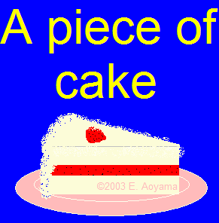
for all n.

We will find that performing almost any linear operation on basis functions of this type to be exceeding simple (more on this later)!

Time Invariance

Q: That’s right! You said that most of the microwave devices that we will study are (approximately) linear, time-invariant devices. What does time invariance mean?

A: From the standpoint of a linear operator, it means that that the operation is independent of time—the result does not depend on when the operation is applied. I.E., if:

then:

where is a delay of any value.

The devices and networks that you are about to study in EECS 723 are in fact fixed and unchanging with respect to time (or at least approximately so).


As a result, the mathematical operations that describe most (but not all!) of our circuit devices are both linear and time-invariant operators. We therefore refer to these devices and networks as linear, time-invariant systems.

