5-3 The BJT as an
Amp and Switch

Q: Since BJTs and MOSFETs are actually quite similar, are they used to build similar things?

A: Yup! We can use BJTs to build amplifiers/oscillators, or to build digital devices.

→ The BJT mode for amplification is Active.

→ The BJT modes for switching are Saturation and Cutoff.

Note again the analogies to MOSFETs!
V_{CC}
V_{I}
V_{O}

For years, the standard digital circuit technology was Transistor-Transistor Logic (TTL).

TTL and CMOS are close cousins!

The Basic
TTL Inverter

Back in my day (a long time ago!) TTL was much faster than CMOS, thus TTL was prevalent.
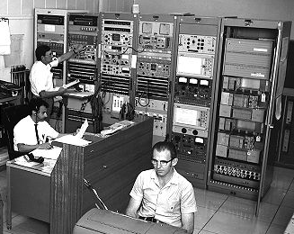

Now, CMOS (in addition to all of its other ideal characteristics) is faster than TTL, thus TTL is basically obsolete.

Q: Does that mean that BJTs are likewise obsolete?

A: NO! For example, BJTs are used in a digital technology called Emitter-Coupled Logic (ECL). ECL is a very fast technology—but also requires very high power!

Mainly though, BJTs are used in amplifier design, as they often can provide higher gain and wider bandwidth than their MOSFET counter parts.

